How to sort lines in text files in Linux | sort Command

The sort command in Linux is used to sort a file, arranging the records in a particular order.
By default, the sort command sorts file assuming the contents are ASCII.
Using options in the sort command can also be used to sort numerically.
sort is a command that sorts text files alphabetically, numerically, by month, in reverse, and removes duplicates
sort command sorts the contents of a text file, line by line.
sort is a standard command-line program that prints the lines of its input or concatenation of all files listed in its argument list in sorted order.
By default, the entire input is taken as the sort key. Blank space is the default field separator.

Syntax of sort Command in Linux
sort [OPTION]... [FILE]...

'options' refer to the various flags and parameters that can be used to customize the sorting behavior, and 'file' is the name of the file to be sorted.

Example:

Let's start with a simple example. Consider a file named 'file.txt' with the following content

cat file.txt

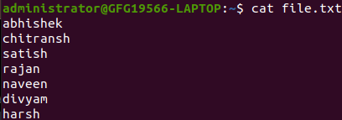
Displaying content of file using cat command
Here we used cat command to display the content inside the file name 'file.txt'.
To sort the lines alphabetically, you can use the following command:

sort file.txt
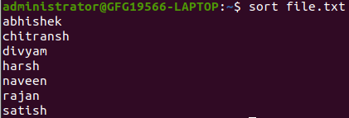
sort lines in text using sort command
Note: This command does not actually change the input file, i.e. file.txt . We can verify this using cat command .
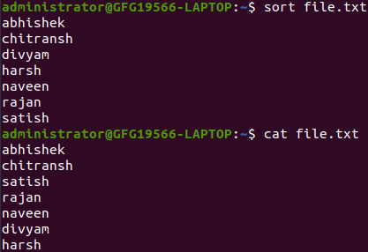
no change is done to real file
Features of sort command
Lines starting with a number will appear before lines starting with a letter.
Lines starting with a letter that appears earlier in the alphabet will appear before lines starting with a letter that appears later in the

alphabet.
Lines starting with a uppercase letter will appear before lines starting with the same letter in lowercase.

Options Available in sort Command
These options help control how the sort command arranges data based on different formats like text, numbers, dates, and duplicates.

Options | Description
-o | Specifies an output file for the sorted data.  Functionally equivalent to redirecting output to a file.
-r | Sorts data in reverse order (descending).
-n | Sorts a file numerically (interprets data as numbers).
-nr | Sorts a file with numeric data in reverse order. Combines -n and -r options.
-k | Sorts a table based on a specific column number.
-c | Checks if the file is already sorted and reports any disorder.
-u | Sorts and removes duplicate lines, providing a unique sorted list.
-M | Sorts by month names.

How to Sort Lines in Text Files with Uppercase and Lowercase Using sort Command
Sort function with mix file i.e. uppercase and lower case: When we have a mix file with both uppercase and lowercase letters then first the upper case letters would be sorted following with the lower case letters.
Example: If we have a text file which has both Uppercase andlowercase characters.

cat mix.txt
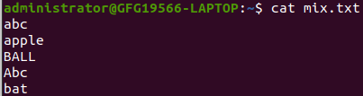
Displaying content of file using cat command
Here we used cat command to display the content inside the file name 'mix.txt'.
To sort the lines alphabetically which contain uppercase and lowercase letters, you can use the following command:

sort mix.txt
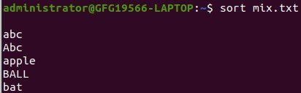
sort uppercase and lowercase lines in text using sort command

How to do Numeric Sorting in Lines in Text Files Using sort Command
By default, 'sort' treats numbers as text and sorts them accordingly. If you want to perform numeric sorting, use the '-n' option:

cat file1.txt

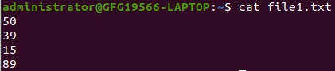
Displaying content of file using cat command
Here we used cat command to display the content inside the file name 'file1.txt'.
Now we will sort the numeric data using sort command as follows.

sort file1.txt
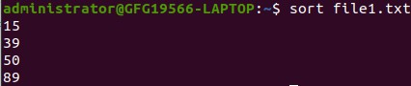
sorting numerical data in linux file

How to Sort Lines in Reverse Order in Linux File Using sort Command
To sort in reverse order, you can use the '-r' option:
Example: If we want to sort lines in reverse order in Linux file we can use sort command with -r option, suppose we have a file name "example.txt" as shown below.

cat example.txt
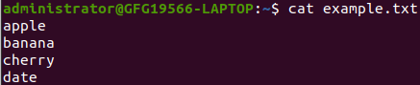
using cat command to display content inside file
Now sorting lines in reverse order using `-r` option in sort command

sort -r example.txt
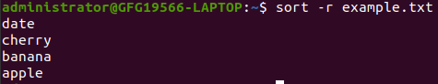
sorting lines in reverse order using -r with sort command

How to sort Specific Fileds in Linux Files Using sort Command
Imagine you have a file named 'employee_data.txt' that contains information about employees in a tab-separated format. Each line represents a record with details such as employee ID, name, department, and salary, separated by tabs. You want to organize this data based on the department and display the results in alphabetical order.
For Example: If our file name is "employee_data.txt" and content inside it is as follows.

cat employee_data.txt
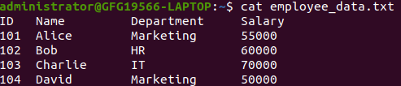
Displaying content of file using cat command
To achieve this, you can use the 'sort' command

sort -k3 employee_data.txt

Explanation:
-k3: This option indicates that the sorting should be done based on the third column (Department).
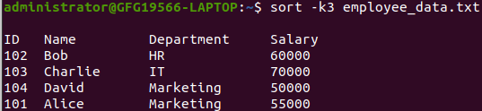
sorting a particular column using sort command
In this example, the employee records are now sorted alphabetically based on the 'Department' column. The 'sort' command, with the custom delimiter, allows you to efficiently organize and analyze tab- separated data, making it a valuable tool for managing structured information in various scenarios.

Application and uses of sort command
The sort command helps organize data easily without changing the original file, making it safe for repeated use.
- It can sort any type of file be it table file text file numeric file and so on.
- Sorting can be directly implemented from one file to another without
the present work being hampered.
- Sorting of table files on the basis of columns has been made way simpler and easier.
- So many options are available for sorting in all possible ways.
- The most beneficial use is that a particular data file can be used many times as no change is made in the input file provided.
- Original data is always safe and not hampered.

